Extra 21-3 Handle the back-button problem in the Halloween Store application

In this exercise, you’ll try using the PRG pattern and timestamps to solve the back-button problem in an ASP.NET application.

Open and test the application

1. Open the XEx21BackButton application in your exercises_extra directory.
2. Run the application and add two or more products to the cart.
3. Select one of the products you just added and click the Remove Item button. Then, click the Back button in your browser to see that the product you just deleted is displayed in the cart again.
4. Click the Continue Shopping button to return to the Order page. Then, click the Go to Cart button to redisplay the cart. Now, you can see that the cart doesn’t include the item you deleted in step 3.

Use the PRG pattern

1. Comment out the statement in the event handler for the Click event of the Remove Item button in the Cart page that displays the cart. Then, add a statement that redirects to the Cart page.
2. Test the application again as described in steps 2 and 3 above. This time when you click the Back button, the Order page is redisplayed with the last item you added since the Cart page wasn’t stored in the cache.
3. Click the Go to Cart button to redisplay the cart. As before, the cart doesn’t include the item that you just deleted.

Use timestamps

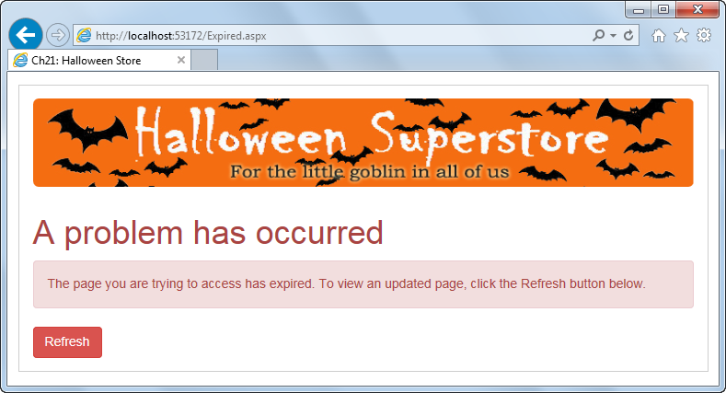

1. Review the aspx code for the Expired page that will be used by this version of the application. This page displays a message as shown above and includes a Refresh button that posts back to the Cart page.
2. Comment out the statement you added to the Cart page in step 5 and uncomment the statement that displays the cart.
3. Add a private method named IsExpired that returns a Boolean value. This method should test the values of a session state item named Cart_TimeStamp and a view state item named TimeStamp. If either of these items is equal to null or if the string values of the two items are equal, the method should return a False value. Otherwise, the method should return a True value.
4. Add a private method named SaveTimeStamps that doesn’t return a value. This method should get the current date and time and then store it in the view state and session state items.
5. Add code to the beginning of the Page_Load method that calls the IsExpired method. If this method returns a True value, the application should be redirected to the Expired page. Otherwise, it should call the SaveTimeStamps method.
6. Add event handlers for the Click event of the Continue Shopping and Check Out buttons. The event handler for the Continue Shopping button should redirect to the Order page, and the event handler for the Check Out button should redirect to the CheckOut1 page. Now, delete the PostBackUrl attributes for both of these buttons.
7. Test the application one more time as described in steps 2 and 3 above. Then, click the Continue Shopping button. This time, the Expired page should be displayed.
8. Click the Refresh button on the Expired page. The Cart page will be redisplayed, and the item you deleted won’t be included in the cart.